26.4: a) False, current divides at junction a.
b) True by charge conservation.
c) True. 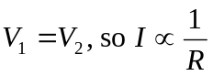
d) False.
e) False. 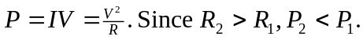
f) True. Potential is independent of path.
g) True. Charges lose potential energy (as heat) in 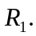
h) False. See answer to (g).
i) False. They are at the same potential.

